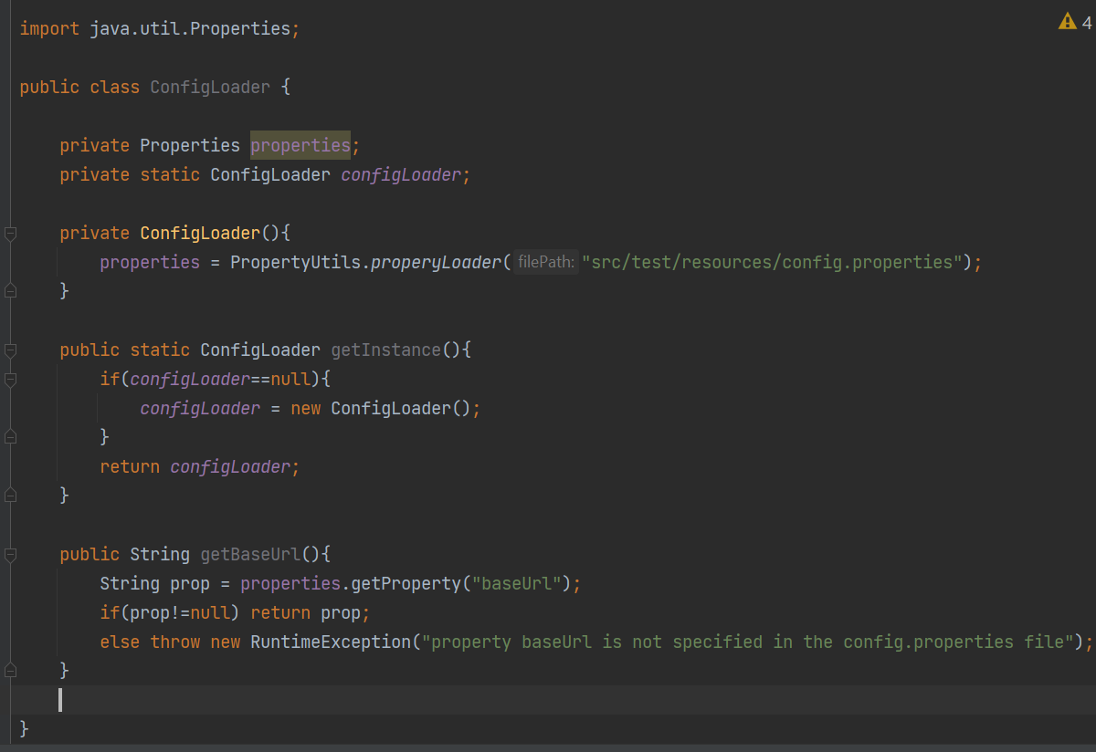

So this class represents **singleton** pattern design. The main aspect is:

1) - The class has a private and meantime static field of its own instance.

It means that you can create an object of this class **only once** (singleton - одиночка) in this class itself and all times when you need it the class will return this particular object using the method.

2)- the class has a private constructor and method that creates the object, this method check if the object created it return the value, and if the object == null then it creates object and then return it